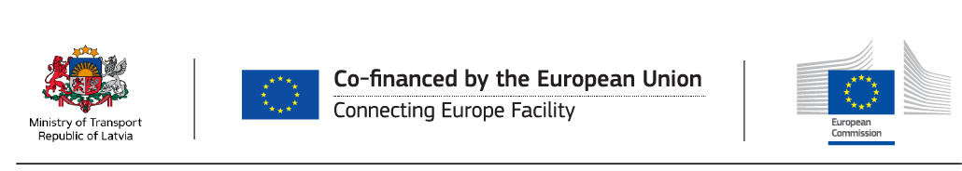
WORKSHOP ON FINANCING OPPORTUNITIES FOR THE TRANSPORT SECTOR
21st October 2016 RIGA
MINISTRY OF TRANSPORT OF THE REPUBLIC OF LATVIA (Gogoļa Street 3)
AGENDA

TIME | SUBJECT | SPEAKERS
09:00-9:30 | Registration
9:30-9:40 | Opening remarks | Ministry of Transport  L.Vītoliņa (ALTUM)
9:40-10:20 | Financing Opportunities under the CEF, EFSI and ESI Funds for the Transport Sector:  - Context and transport policy priorities  - Opportunities under CEF: calls for proposals, including the upcoming CEF call, blending, innovative financial instruments  - Objectives of and opportunities under the Investment Plan for Europe for the transport sector  - Objectives of and opportunities under the European Structural and Investment (ESI) Funds for the transport sector  - Financial instruments under ESI Funds | Mr S. Ouaki (EC DG-MOVE)  Mr A. Polese (EC DG-REGIO)
10:20-11:00 | European Fund for Strategic Investments: what is EFSI, how to get support under EFSI, eligible projects, best practices: relevant executed projects  Possibilities for bundling projects in transport sector, examples of best praxis - in what type of transport projects it has worked, main features of such projects and financing structures | V.Legzdiņš (EIB)
11:00-11:10 | Q&A
11:10-11:20 | Coffee (room 415)
11:20-11:45 | Local situation of PPPs and opportunities for blending financial sources (EFSI, EISI, PPP, Other public, private funds), examples and best praxis. in what type of transport projects it has worked, unusual/new blending approaches; main features of such projects and financing structures.  Successful projects: financial model/ PPP structure; key attributes/ checklist for successful projects; typical project roadmap; key learnings. | Mrs B. Apine (PwC)
11:45-12:05 | The Latvian context:  - Transport investment needs potential project pipeline for EFSI, Latvian PPP legislation | Ministry of Transport
12:05-12:10 | Q&A
12:10-13:00 | Light lunch (room 415)
13:00-14:40 | Discussion/ Bilateral meetings on specific project  (Room 478) | Project promoters, private investors,  EC, EIB,  Ministry of Transport

